*Verzameling afvinklijst:*

***Cd’s van***





**Standaard CD’s**

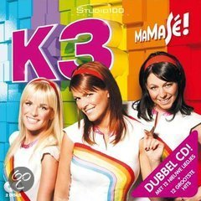

[MaMaSé! (dubbel cd)](http://www.studio100fan.eu/encyclopedie/MaMaS%C3%A9%21_-_K3_%28cd-album%29) 2009 🞏

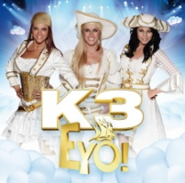

[Eyo!](http://www.studio100fan.eu/encyclopedie/Eyo%21_-_K3_%28cd-album%29) 2011 🞏

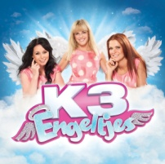

[Engeltjes](http://www.studio100fan.eu/encyclopedie/Engeltjes_-_K3_%28cd-album%29) 2012 🞏

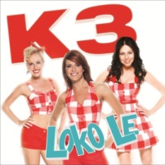

[Loko Le](http://www.studio100fan.eu/encyclopedie/Loko_Le_-_K3_%28cd-album%29) 2013 🞏

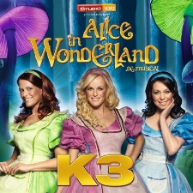

Alice in Wonderland 2011 🞏

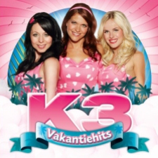**Overige CD’s**

[Vakantiehits](http://www.studio100fan.eu/encyclopedie/Vakantiehits_2012_-_K3_%28cd-album%29) 2012 🞏

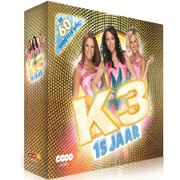

[CD-box: 15 jaar K3](http://www.studio100fan.eu/encyclopedie/15_jaar_K3_-_K3_%28cd-box%29) 2013 🞏

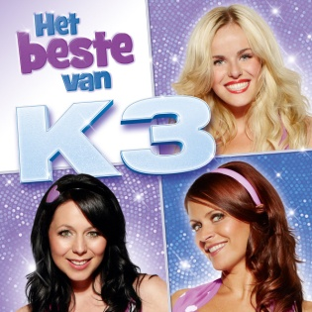

Het beste van K3 2015 🞏