*Verzameling afvinklijst:*

***Cd’s van***





**Standaard CD’s**

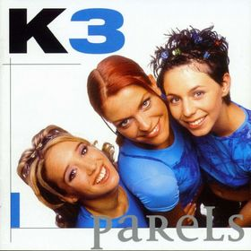

Parels 1999 🞏

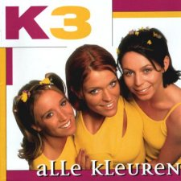

[Alle kleuren](http://www.studio100fan.eu/encyclopedie/Alle_kleuren_-_K3_%28cd-album%29) 2000 🞏

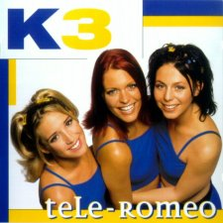

[Tele-Romeo](http://www.studio100fan.eu/encyclopedie/Tele-Romeo_-_K3_%28cd-album%29) 2001 🞏

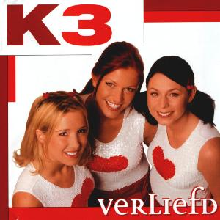

[Verliefd](http://www.studio100fan.eu/encyclopedie/Verliefd_-_K3_%28cd-album%29) 2002 🞏

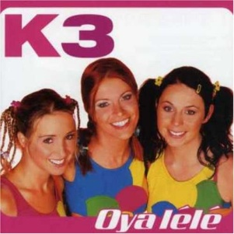

[Oya lélé](http://www.studio100fan.eu/encyclopedie/Oya_l%C3%A9l%C3%A9_-_K3_%28cd-album%29) 2003 🞏



[De wereld rond](http://www.studio100fan.eu/encyclopedie/De_wereld_rond_-_K3_%28cd-album%29) 2004 🞏



[Kuma he](http://www.studio100fan.eu/encyclopedie/Kuma_he_-_K3_%28cd-album%29) 2005 🞏



[Ya ya yippee](http://www.studio100fan.eu/encyclopedie/Ya_ya_yippee_-_K3_%28cd-album%29) 2006 🞏



[Kusjes](http://www.studio100fan.eu/encyclopedie/Kusjes_-_K3_%28cd-album%29) 2007 🞏

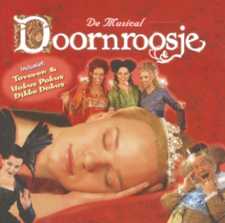

Doornroosje 2002 🞏

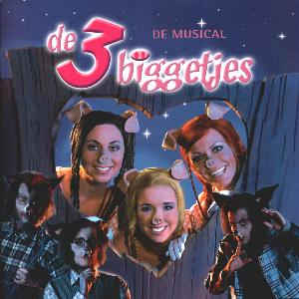

De 3 biggetjes 2003 🞏

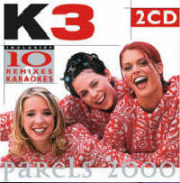**Limited editions**

[Parels 2000](http://www.studio100fan.eu/encyclopedie/Parels_2000_-_K3_%28cd-album%29) 2000 🞏

(dubbel cd)

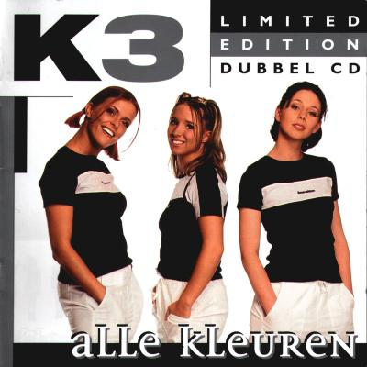

[Alle kleuren](http://www.studio100fan.eu/encyclopedie/Alle_kleuren_LE_-_K3_%28cd-album%29) 2001 🞏

(dubbel cd)



[Tele-Romeo](http://www.studio100fan.eu/encyclopedie/Tele-Romeo_LE_-_K3_%28cd-album%29) 2002 🞏

(dubbel cd)

**Overige CD’s**

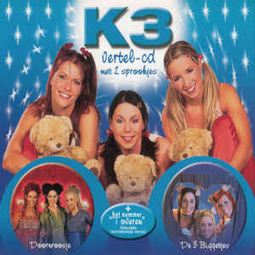

K3 vertel cd 2003 🞏



[5 jaar K3](http://www.studio100fan.eu/encyclopedie/5_jaar_K3_-_K3_%28cd-album%29) 2004 🞏

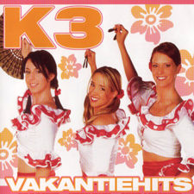

[Vakantiehits](http://www.studio100fan.eu/encyclopedie/Vakantiehits_2005_-_K3_%28cd-album%29) 2005 🞏



[Vakantiehits vol. 1](http://www.studio100fan.eu/encyclopedie/Vakantiehits_volume_1_-_K3_%28cd-album%29) 2008 🞏



[Vakantiehits vol. 2](http://www.studio100fan.eu/encyclopedie/Vakantiehits_volume_2_-_K3_%28cd-album%29) 2009 🞏