*Verzameling afvinklijst:*

***Dvd’s van***





**Shows**

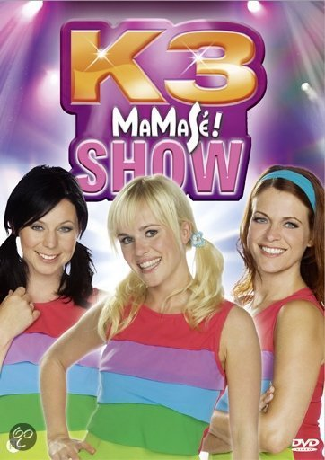

[MaMaSé! show](http://www.studio100fan.eu/encyclopedie/MaMaS%C3%A9%21_show_-_K3_%28DVD%29) 2010 🞏

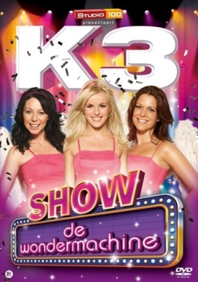

[K3 en de Wondermachine](http://www.studio100fan.eu/encyclopedie/K3_en_de_Wondermachine_-_K3_%28DVD%29) 2011 🞏

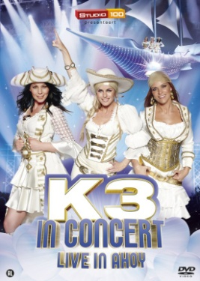

[K3 in Concert (Live in Ahoy)](http://www.studio100fan.eu/encyclopedie/K3_in_Concert_%28Live_in_Ahoy%29_-_K3_%28DVD%29) 2012 🞏

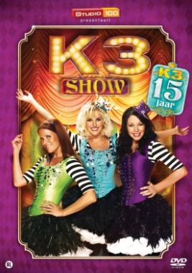

[K3 verjaardagsshow 15 jaar](http://www.studio100fan.eu/encyclopedie/K3_verjaardagsshow_15_jaar_-_K3_%28DVD%29) 2013 🞏

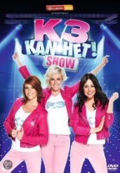

K3 kan het! Show 2015 🞏

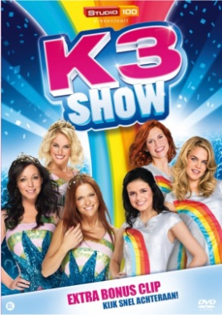

10.000 luchtballonnen 2015 🞏

Afscheidsshow

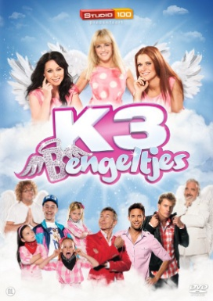**Films**

[K3 Bengeltjes](http://www.studio100fan.eu/encyclopedie/K3_Bengeltjes_-_K3_%28DVD%29) 2013 🞏



[K3 Dierenhotel](http://www.studio100fan.eu/encyclopedie/K3_Dierenhotel_-_K3_%28DVD%29) 2014 🞏

**Hallo K3**



[Volume 1](http://www.studio100fan.eu/encyclopedie/Volume_1_-_Hallo_K3_%28DVD%29) 2010 🞏



[Volume 2](http://www.studio100fan.eu/encyclopedie/Volume_2_-_Hallo_K3_%28DVD%29) 2011 🞏



[Volume 3](http://www.studio100fan.eu/encyclopedie/Volume_3_-_Hallo_K3_%28DVD%29) 2011 🞏

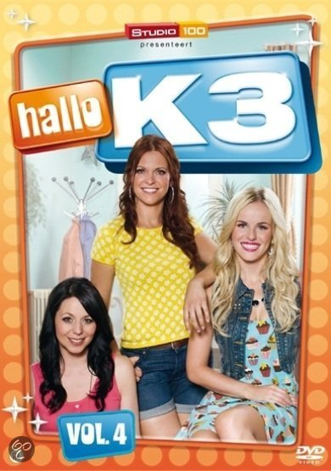

[Volume 4](http://www.studio100fan.eu/encyclopedie/Volume_4_-_Hallo_K3_%28DVD%29) 2011 🞏

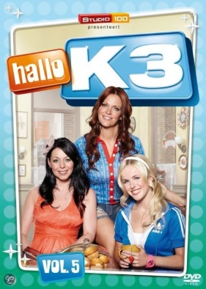

[Volume 5](http://www.studio100fan.eu/encyclopedie/Volume_5_-_Hallo_K3_%28DVD%29) 2012 🞏



[Volume 6](http://www.studio100fan.eu/encyclopedie/Volume_6_-_Hallo_K3_%28DVD%29) 2012 🞏

[Volume 7](http://www.studio100fan.eu/encyclopedie/Volume_7_-_Hallo_K3_%28DVD%29) 2013 🞏

**De wereld van K3**

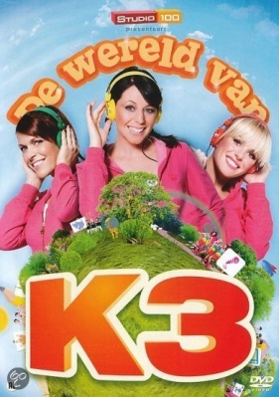

Volume 1 2010 🞏

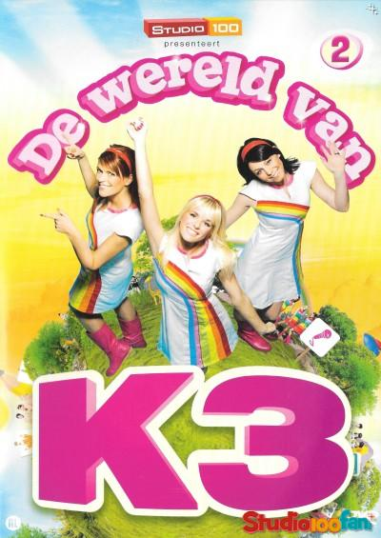

[Volume 2](http://www.studio100fan.eu/encyclopedie/De_wereld_van_K3_volume_2_-_K3_%28DVD%29) 2012 🞏

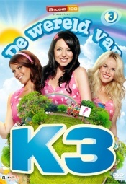

[Volume 3](http://www.studio100fan.eu/encyclopedie/De_wereld_van_K3_volume_3_-_K3_%28DVD%29) 2012 🞏

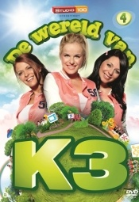

[Volume 4](http://www.studio100fan.eu/encyclopedie/De_wereld_van_K3_volume_4_-_K3_%28DVD%29) 2012 🞏

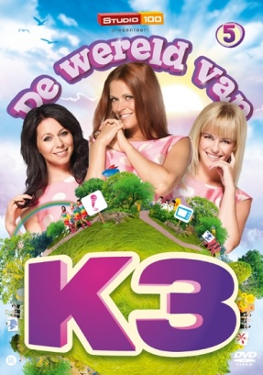

[Volume 5](http://www.studio100fan.eu/encyclopedie/De_wereld_van_K3_volume_5_-_K3_%28DVD%29) 2013 🞏

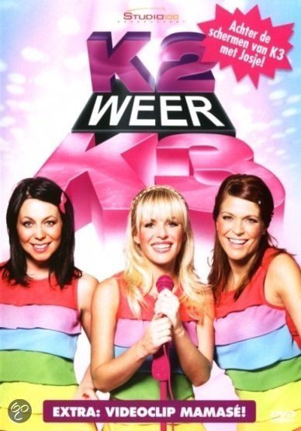**Specials**

[K2 weer K3](http://www.studio100fan.eu/encyclopedie/K2_weer_K3_-_K3_%28DVD%29) 2010 🞏

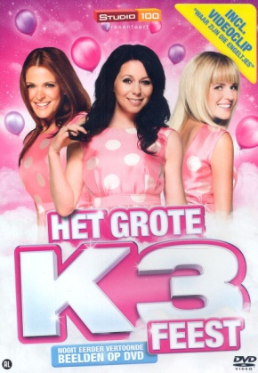

Het grote K3 feest 2012 🞏

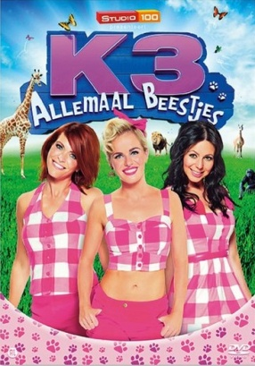

K3 allemaal beestjes 2013 🞏

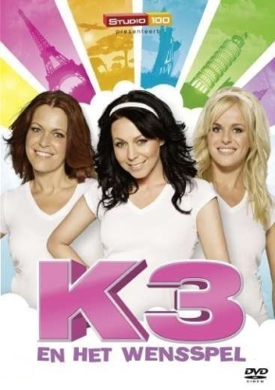

[K3 en het Wensspel](http://www.studio100fan.eu/encyclopedie/K3_en_het_Wensspel_-_K3_%28DVD%29) 2010 🞏

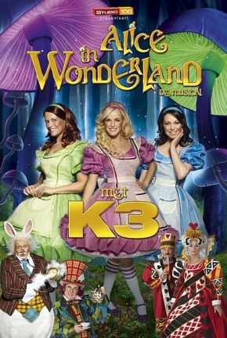

Alice in Wonderland (musical) 2011 🞏

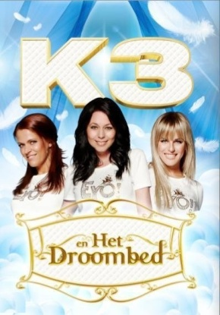

[K3 en het droombed](http://www.studio100fan.eu/encyclopedie/K3_en_het_droombed_-_K3_%28DVD%29) 2012 🞏

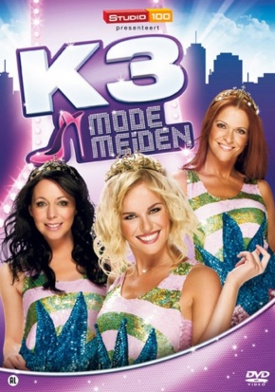

[Modemeiden](http://www.studio100fan.eu/encyclopedie/Modemeiden_-_K3_%28DVD%29) 2013 🞏



[K3 in Nederland](http://www.studio100fan.eu/encyclopedie/K3_in_Nederland_-_K3_%28DVD%29) 2014 🞏

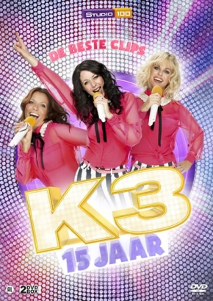

15 jaar De beste clips 2013 🞏